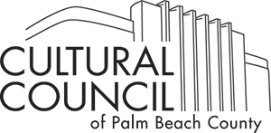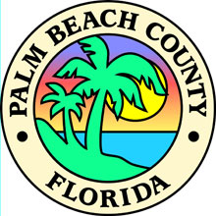

Grants Department Schedule of Events
Category B, CII and C1
FY 18/19
(Dates subject to change)

Trainings are in the Cultural Council’s ETC room unless noted otherwise

Meeting Location: Cultural Council, 601 Lake Avenue, Lake Worth, Florida 33460

October 1, 2018 FY 18/19 Grant Period Begins

October 1, 2018 –
September 30, 2019 Accepting Cultural Expeditions Applications

October 31, 2018 DEADLINE FY17/18 Final Reports due no later than 11:59pm for Category
B, CII and CI

November 19, 2018 DEADLINE FY18/19 Category CI Round 2 applications due 11:59pm

January 4, 2019, 9am-3pm Category C1 Round 2 Panel Interviews

January 25, 2019, 10am FY18/19 Category B and CII reimbursement training
RSVP vjackson@palmbeachculture.com

January 25, 2019, 2pm Category C1 Contract signing and reimbursement training
RSVP vjackson@palmbeachculture.com

February, 2019 FY19/20 Category B and CII applications available online

Mar 29, 2019 DEADLINE FY 19/20 Category B and CII applications due 11:59pm

April 12, 2019 FY19/20 Category B panel interviews

April 15, 2019 FY18/19 Category B, CII and CI interim reports due 11:59pm

April 25, 2019 FY19/20 Category CII panel interviews

May 2, 2019 FY19/20 Category B panel interviews

June 3, 2019 10am FY19/20 Category C1 application training
RSVP vjackson@palmbeachculture.com

June 3, 2019 FY19/20 Category C1 Round 1 applications available online

June 6, 2019, 10am FY19/20 Cat B & CII Contract Training

June 7, 2019, 2pm FY 19/20 Cat B & CII Contract Training

June 21, 2019 DEADLINE – FY 19/20 Category B & CII Exhibits A & B-1 revisions

June 27, 2019, 10am Dina Baker Fund application training
RSVP vjackson@palmbeachculture.org

July 8, 2019 DEADLINE FY19/20 Category CI applications due (only accepting applications once in 2019)

July 12, 2019 DEADLINE – Category B & CII signed contracts

August 5, 2019 DEADLINE Dina Baker applications due 11:59pm

August 9, 2019 FY19/20 Category C1 Panel Interviews

September 12, 2019, 10am Category C1 Final Report Training
September 12, 2019, 2pm Category B & CII Final Report Training

September 13, 2019 DEADLINE FY18/19 – All Final Reimbursements due by 11:59pm

October 31, 2019 DEADLINE FY18/19 Final Reports due no later than 11:59pm for Category
B, CII and CI

