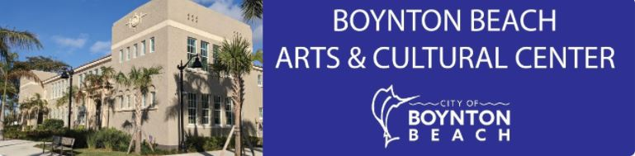

Black Creativity in Art and Words
January 13 – February 26
Boynton Beach Arts & Cultural Center, 125 East Ocean Ave, Boynton Beach, 33435
Application Due: December 20, 2021, 5 PM
Boynton Beach and other Palm Beach County Artists Only
Click Here to Apply: https://bit.ly/BlackArtWords
The Public Art Program and the Arts & Cultural Center of Boynton Beach invites you to exhibit and sell your artwork in the exhibition “Black Creativity in Art and Words”. Each artist can submit three artworks or short poems/lyrics for consideration.
The exhibition is open to all artists from with heritage in the African diaspora and living, working or studying in Palm Beach County. Each artist should apply in one of two categories: working artist or student artist. A working artist has been practicing their craft at least three years and is over 21 years old. A student artist is currently studying in a university or high school program and is at least 15 years old.
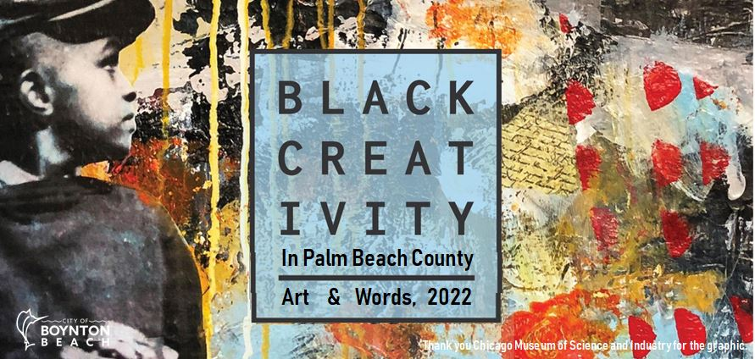
The gallery of the Arts & Cultural Center is better prepared for hanging two dimensional artworks or printed text, but we will strive to accommodate 3D elements.
The artwork must be handmade or designed by the artist, be well constructed, and meet basic artistic criteria for works of art or craft. There are no restrictions on the type of artwork, but the content cannot offend community standards. The City reserves the full rights to determine if the artwork meets the criteria for display and to remove any artwork at any time.
To sell the artwork, a potential buyer will be provided with the artist contact information. The City will not act as the seller and will not require any fee from the artists.
Schedule
Last Day to Submit an Application Dec 20, 2021
Last Day Application Approved Dec 23, 2021
Bring Artwork to the Arts & Cultural Center January 7 or 8, 2022
Opening Reception January 13, 5:30 – 8:00 PM
Special Event (To be Announced) January 15
Exhibition Closes February 25, 5:00 PM
Last Day to Artist Pickup February 26 and 28, 2022
Gallery Hours
Monday - Friday, 10 am to 8 pm.
Saturday, 10 am to 1 pm (Perhaps until 5 PM).
Additional terms
The full extent of the City's liability is the declared value of the artwork. The City is only responsible for the artwork from the time of delivery to the time of pick-up, but no later than February 28, 2022 at 8 PM. The artist, not the City, is responsible for the delivery and pick-up from the Arts & Cultural Center.
The artist stipulates that artist owns the copyright and grants the City the right publish images of the artworks for all non-commercial purposes related to promoting the exhibition. The City will identify the artist and artwork except for overall images of exhibition space with the artworks.
Application Due: December 20, 2021
Click Here to Apply: https://bit.ly/BlackArtWords

