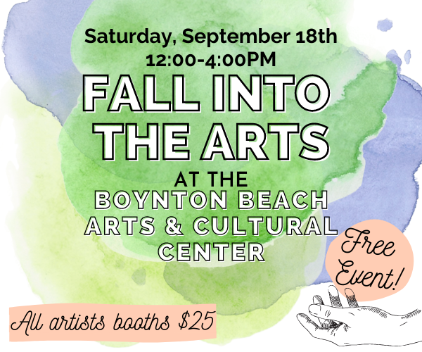
Fall into the Arts: September 18th 12:00-4:00pm
Boynton Beach Arts & Cultural Center, 125 E. Ocean Ave

About Event:
The Boynton Beach Arts & Cultural Center presents its first free open house event, Fall into the Arts! This free event will be a celebration of the arts in our community, highlighting the program and activities offered at the Arts & Cultural Center, and a demonstration of what makes Boynton Beach a great place to live. Featuring art, music, dance, and cultural program demos and performances from our talented instructors, plus; hands-on art making, ukulele jam sessions, a Story Slam competition, an all-ages chess tournament, and a live DJ, presenting a variety of activities and events to inspire and engage our audience.
As a showcase of happenings in Boynton Beach and surrounding area, this event will bring adults, children, families, seniors and out of towners together under one roof. In addition to artist vendors, a highlight will be the eateries serving their specialties from local culinary scene.

Vendor Opportunity:
We are offering an exciting opportunity to a limited number of artists to feature your art to a potential new audience, promote your brand, and engage with other artists at the Arts & Cultural Center’s Fall into the Arts event. While performances are happening and demonstrations take place, you will be in the Event Hall with other vendors, each with your own space. Bring your works of art with you and display them on the table provided, or bring your own backdrop to stand out from the crowd!

Info:
Booth space: 8x8 sq. ft. tables provided; no tent necessary
Price: $25.00
Set up/break down times: 10am/4-5pm
No insurance required; will need to sign a notarized waiver
You must be present for the entire event to manage your table

COVID policies:
You may not come to the event if you have been exposed to, have, or exhibit COVID-19 symptoms. All vendors will be required to wear masks.

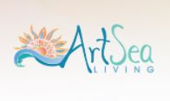
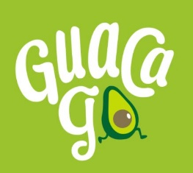
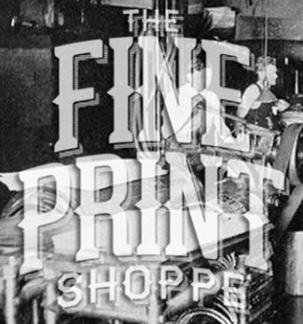
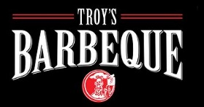
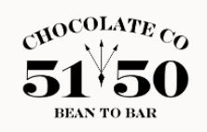
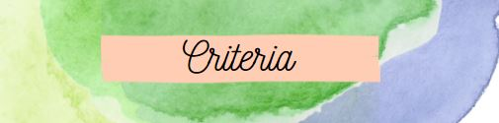
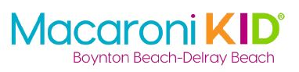
Current participants include:

Your work will be evaluated based on your use of high-quality materials and techniques to make your work durable and market ready. Additionally, your items are priced to provide a balance of quality and accessibility for our shoppers. All work must be unique and unquestionably your own, as well as appropriate for our audience.

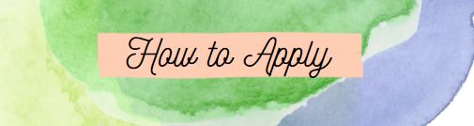
We will not accept work from wholesale distributors, franchises, products with licensed imagery and brands or direct sales/ multi-level-marketing.

Please send at least 4 clear images of your work with prices; all social media handles; and any additional information to: InbergV@bbfl.us by September 7th.

Vendors will be approved on a first come first served basis
For questions call (561) 742-6230 or email InbergV@bbfl.us

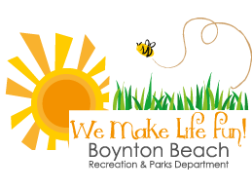
Thank you for your application!

